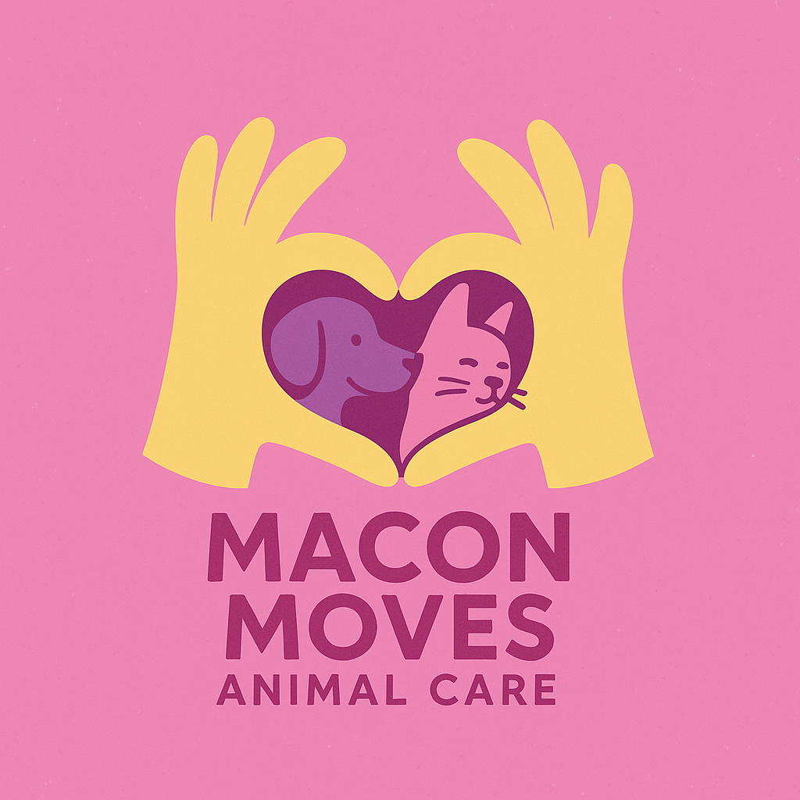

Trap Neuter Return (TNR) Consent Form

Hello and thank you for taking the first step to having your outdoor kitties live a healthy and happy life. Any time we work on a cat colony we require the cats to be combo tested for FeLV/FIV virus. If a cat tests positive, the cat must remain indoors its entire life or be humanely euthanized. These viruses attack the immune system which causes an outdoor cat to experience a long painful exit from this world. The viruses are extremely contagious and can be passed onto countless other felines in the wild. The ethical thing to do would be to humanely euthanize.

Macon Moves Animal Care provides the traps and will handle the transport of the cats to the spay/neuter clinic. All cats that test negative will be sterilized, vaccinated, flea treated and ear tipped so everyone will easily know the cats have been vetted.

If you agree to participate in our TNR Program please complete the information below.

Name _______________________________

Address _________________________________

Phone # ______________________

Signature _____________________ Date __________

Please present this signed form upon our arrival or you may email it to:

MaconMovesAnimalCare @gmail.com

Please call 828-200-9686 if you have any questions

